EE3180: Progress Blog

Week 3:
- Objective:
  - Divide the group into 3 subgroup: Visual tracking using camera, Lidar tracking using computer cloud and integrate both
  - Lidar tracking: Read the vision-based MOT paper (VoxelNeXt: Fully Sparse VoxelNet for 3D Object Detection and Tracking)
  - Run GitHub code. Understand the output
Group: Try to run the test code and understand the output.
- Individual:
  - Ask the prof to use the budget for buying a GPU. Use the project money.
  - Coding:
    - Launch the virtual environment: conda activate pytorch
    - To use pytorch, use code: python3 then can import pytorch
    - To check the GPU constantly, use the code: nvidia-smi -l
    - To check the Nvidia cuda compiler driver: nvcc --version
    - Remove automatically other dependencies: sudo apt-get autoremove
    - To show the list of packages installed: pip list
    - Remove unused packages: conda clean –all
    - To check the version of Ubuntu system: lsb_release -a
    - Clear pip cache: pip cache purge
    - Clear terminal: Ctrl + L
    - Exit python in terminal: Ctrl + d
    - Exit a process in terminal: Ctrl + C
    - Frozen screen: Ctrl + Alt + Esc; Fn + Print Sc + Press R E I S U B

    - To suppress warnings temporarily (the code: from spconv.pytorch.core import SparseConvTensor): import warnings, warnings.fillterwarnings(“ignores”, category=FutureWarning)

  - Objectives:
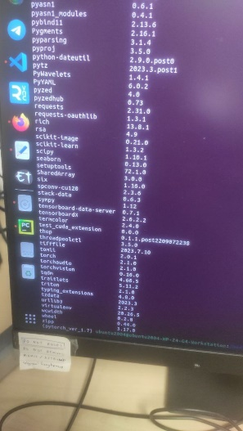
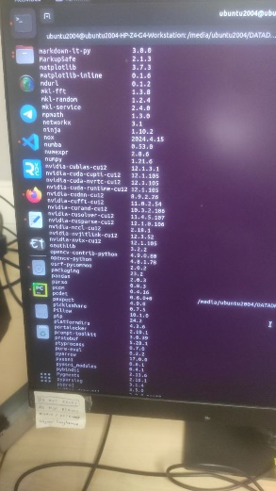
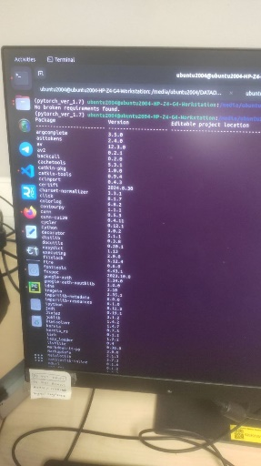
    - Download all the packages needed, list of packages:

    - Run the setup.py so can import spconv, from spconv.pytorch.modules import SparseModule, can import cumm and pcdet, etc
    - Download and extract the dataset to DATADRIVE (got more memory to store around 50GB of data)
    - The data structure: (under OpenPCDet/data/)
Kitti
│
├── ImageSets
│ ├── train.txt
│ ├── val.txt
│ └── test.txt
│
├── training
│ ├── calib
│ ├── image_2
│ ├── image_3
│ ├── label_2
│ ├── velodyne
│ └── planes (optional)
│
└── testing
├── calib
├── image_2
├── image_3
└── velodyne

Week 4:
- Objective:
  - Fix indentation error in python, replace Tab with 4 spaces solve it
  - Update the root_path inside kitti_dataset.py: the data is inside ../OpenPCDet/data/kitti
  - Update the DATA_PATH inside kitti_dataset.yaml: the path is ../OpenPCDet/data/kitti
- Issue:
  - Path Error in kitti_dataset.py: Wrong calibration file path or missing calibration data led to issues in the training loop.
    - Changes: Updated the paths in the dataset configuration (under function _init_(), root_path = …) to correctly locate calibration files and lidar data.
  - AttributeError in kitti_dataset.py: KittiDataset object did not have a get_calib_file method.
    - Changes: Added or modified the get_calib_file method to handle calibration file fetching properly.
  - DataLoader Exception Handling: The fetcher.fetch(index) step caused an error in the worker process.
    - Changes: Investigated and handled potential issues in the __getitem__ function, particularly with calibration and loading lidar points.
  - Training Process Interrupted
    - Changes: Ensure proper loading of point cloud, calibration, and image data.
- Data Preparation:
  - Run the code (need to be in the directory ../VoxelNeXt-master): python -m pcdet.datasets.kitti.kitti_dataset create_kitti_infos tools/cfgs/dataset_configs/kitti_dataset.yaml
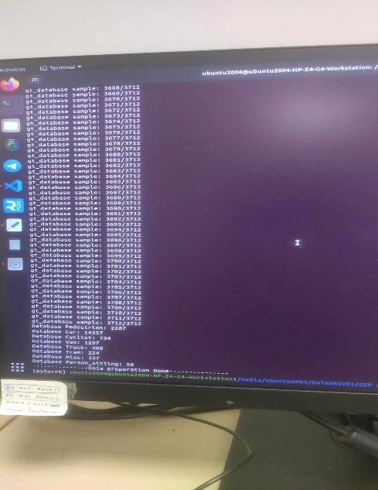
  - Result: show the data contains how many pedestrian, car, etc as shown in the image

Week 5:
- Objectives:
  - Train the model
  - See the results when test the pretrained models

- Training the model:
  - The train_model in file: tools/train_utils/train_utils.py orchestrates the training loop, handling epochs and logging

  - Run the code: python train.py --cfg_file "/media/ubuntu2004/DATADRIVE1/DIP 2024/DIP-2024/Lidar tracking/VoxelNeXt-master/tools/cfgs/kitti_models/voxelnext.yaml"

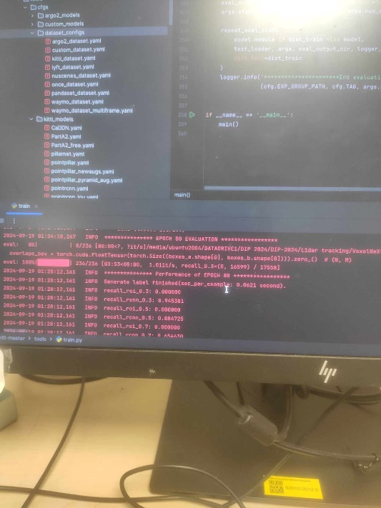
  - Results: The model was saved for each checkpoints with the name: checkpoint_epoch_80.pth under the folder: …/output/tools/cfgs/kittimodels/voxelnext/default/ckpt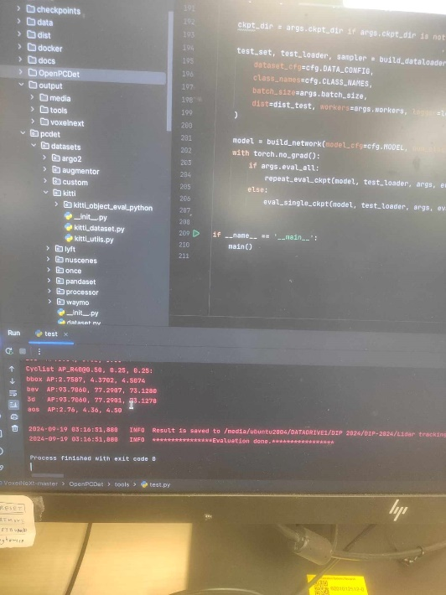

Week 6:
- The VoxelNext github only provides detection model, not the tracking one. Need to use the CenterPoint github for tracking model.
- Install and set up the environment: centerpoint
- Download the nuscenes dataset, the kitti dataset detection model don’t have tracking code
- Configure the correct environment for Centerpoint:
  - Need to change the path of the cuda version to cuda-11 by running script: source activate_cuda11.sh (inside directory: anaconda3/envs/centerpoint/bin)
  - In base environment, change back to cuda-12.6: source ~/.bashrc
  - To check the path: echo $PATH

- Uploading the model to Electerm:
  - When upload the file, the data will be temporarily stored inside the folder Computer/temp

Week 7: Data collection
- We divide into 2 groups, each with 5-6 people. The supervisor uses the robot with lidar camera to capture each person data: both lidar and cv.
  - The cv data is then generated the bounding boxes between each person and the id.
  - The lidar data still needs time to be processed the correct nuscenes format.
Week 8: Visualization on nuscenes point cloud .pcd file
- I converted nuscene json file to get the .pcd point cloud file. Run the code convert_nuscenes_to_pcd.py inside folder Testing
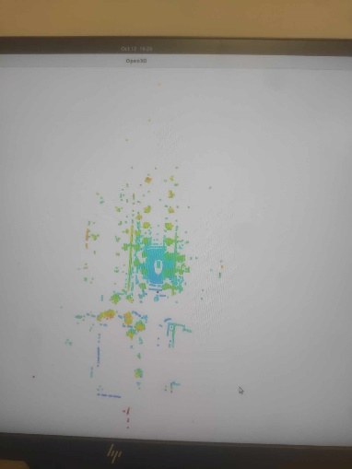
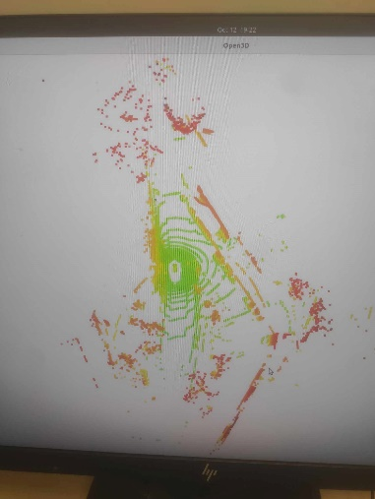
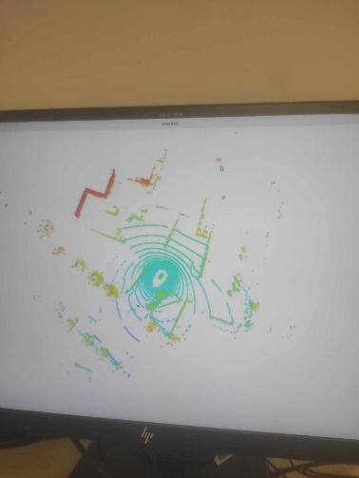
- I used Open3D to generate images in test dataset (v1.0-test/converted_pcds)

(from left to right: scene 1,2,3)
- I visualize the shape of gt_boxes in v1.0-trainval to see if the format is correct:
- The shape is (N,9) where (based on the function __call__ inside anaconda3/…/det3d/datasets/pipelines/preprocess.py):
  - x, y, z: Center coordinates in 3D space
  - w, l, h: Width, length, height dimensions
  - rotation_y: The rotation around the y-axis (in radians)
  - velocity_x, velocity_y: The velocities in the x and y directions
- I added the print statement for shape of gt_boxes in det3d/core/sampler/sample_ops.py
- I visualize the results by generating png with bounding box, inside nuscenes-devkit/python-sdk/nuscenes/eval/detection/evaluate.py, inside the class DetectionEval, add another param: scene_name to filter the scene for visualization.
- The scene number in v1.0-trainval: scene-0001, scene-0002, … scene-1110.
- The visualize code is inside: python-sdk/nuscenes/eval/detection/render.py
Week 11:
- Continue to debug the training for CenterPoint Kitti, inside the pcdet/model/dense_heads/centerpoint_head_single.py, run in pycharm. Need the heatmaps to be in shape (3,400,352)
Week 13:
- Continue debug the pub_test.py inside pycharm, loop through many sample inside CenterPoint/tools/convert_kitti_smth.py

